Abstract—We show how to build a simple version of the classic Chua’s circuit. The goal is to build Chua’s circuit quickly and easily. To this end, only off the shelf component values are used. The inductor in Chua’s circuit is replaced by a single op-amp gyrator circuit. All components can be obtained from your local electronics store (RadioShack in the United States). We also show you can use a computer’s soundcard to sample the chaotic waveforms into MATLAB. Autocorrelation is computed and this provides some valuable insights into chaos.
A Components-Off-The-Shelf Single Op-Amp Gyrator Implementation of Chua’s Circuit
Bharathwaj Muthuswamy, Tamara Blain and Leon O. Chua (?)

Index Terms—Nonlinear circuits and systems, chaos.

INTRODUCTION
IN this paper, we propose a truly components-off-the-shelf (COTS) implementation of Chua’s circuit. The classic version of Chua’s circuit is the paradigm for generating chaotic attractors [1]. A schematic of Chua’s circuit is shown in fig. 1.
However it is difficult to obtain the precise inductance values required for chaotic attractors. A solution is to replace the inductor with a gyrator circuit [2]. Although the solution in [2] uses only one (out of 5) non-standard component values (C of 23.5 uF), it has a two op-amp implementation of the gyrator. In this paper, we propose a simpler gyrator implementation. Specifically:
- We use only one op-amp for the gyrator.
- All components are easily obtained. In the United States of America, you can build this circuit out of components you obtain from RadioShack. A parts list for RadioShack is included at the end of this paper.
The pre-requisites for reading this paper are a basic electronics course and an understanding of frequency response for circuits. The organization of the paper is: we first give a brief overview of Chua’s circuit and show a circuit with typical component values. In the next section, we discuss a gyrator implementation of the inductor and derive the expression for the impedance of the gyrator. We relate this expression to the impedance of an inductor and then use the expression to select off-the-shelf values for the passive components (resistors and capacitors) in the gyrator. Next we simulate the circuit using National Instruments’ MultiSim suite. A 30-day fully-functional trial version of the software can be downloaded from [3]. We then build the circuit and show some oscilloscope waveforms. This is followed by a sample instructional application of this circuit. We conclude the paper with a parts list from RadioShack and future work.

Introduction to CHUA’s CIRCUIT

The Circuit
Fig. 1 shows the schematic of Chua’s circuit. The equations governing Chua’s circuit are shown below.
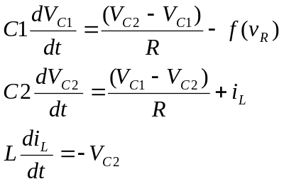
Here,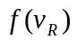denotes the current-voltage characteristics of a nonlinear resistor (called the Chua diode).
This circuit was specifically designed by Leon O. Chua for chaotic behavior [1]. In this paper, we will concentrate on building the circuit quickly and easily. Fig. 2 shows the circuit with some typical component values.
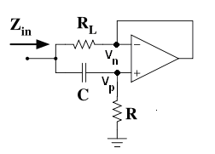
Fig. 3. Gyrator simulating an inductance.

The Gyrator

Impedance Derivation
Fig. 3 shows a schematic of the gyrator for replacing the inductor [4]. We will derive the equivalent impedance of the gyrator as seen from the input terminals (refer to Fig. 3). Using Thevenin’s theorem, we can write an expression for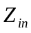:
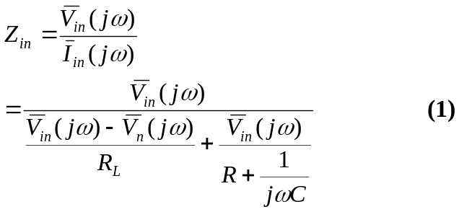
Assuming the op-amp is operating in the linear region:

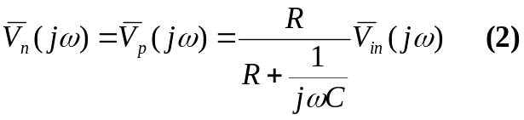
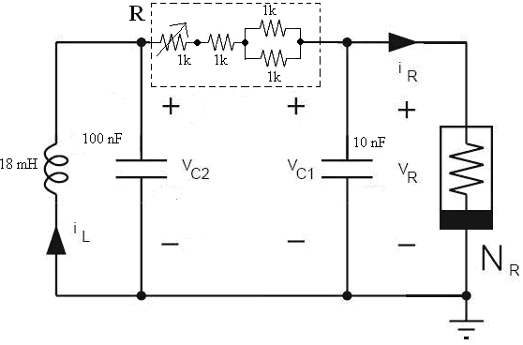
Fig. 2. Chua’s circuit with some typical component values. The capacitors are 5% tolerance, we have replaced R with a 1k potentiometer in series with 1.5k. We use off-the-shelf resistors to construct the 1.5k resistor. The Q of the inductor is about 50.
Substituting for 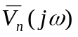in terms of 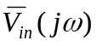 in equation (1) and simplifying:
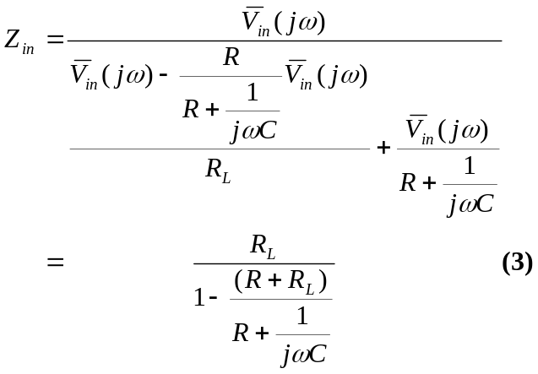 Assuming 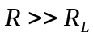:
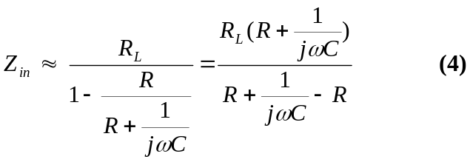
Simplifying, we have:

W e will now relate (5) to the impedance of an inductor.

Inductor Model
Fig. 4 shows the equivalent circuit for (5). We would like to obtain an inductance of 18 mH (refer to Fig. 2).

Table 1 below shows some off-the-shelf values for 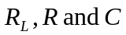. Notice that 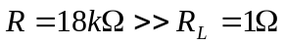.
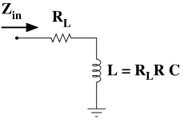
Fig. 4. Equivalent impedance of the gyrator circuit

MULTISIM SIMULATION RESULTS
Fig. 5 shows the time domain and phase space plot of a chaotic attractor from the simulated circuit. The MultiSim10 simulation file can be downloaded from [5]. You tune the circuit by changing the value of R (refer Fig. 2). In our case, we used a 1k potentiometer in series with 1.5k for R (refer to Fig. 2).

SAMPLE WAVEFORMS FROM THE CIRCUIT

SAMPLE INSTRUCTIONAL APPLICATION

CONCLUSION
Acknowledgment
Many thanks to Prof. Pravin Varaiya for insightful discussions on chaos. Prof. Joos Vandewalle was very helpful in providing valuable comments. Many thanks to the students in EE100 Summer 2007 at the University of California, Berkeley. They provided valuable feedback on how to build a simple off-the-shelf version of Chua’s circuit.
References
- Leon O. Chua, “The Genesis of Chua’s Circuit”, in Archiv fur Elektronik und Uebertragungstechnik , vol. 46, no. 4. pp. 250-257, 1992.
- L.A.B. Torres and L.A. Aguirre. “Inductorless Chua’s Circuit”, in Electronics Letters, vo. 36, no. 23. pp. 1915 – 1916, 2000.
- National Instruments Electronics Workbench website. (2007, August 15). [Online]. Available: http://www.ni.com/multisim/
- Gyrator – Wikipedia (2007, August 16). [Online]. Available: http://en.wikipedia.org/wiki/Gyrator
- MultiSim10 Simulation of Chua’s Circuit (2007, August 16). [Online]. Available:
TABLE I
Component Values for GYRATOR
Symbol | Value
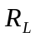 | 1 ohm
 | 18 kohm
 | 1 uF

Bharathwaj Muthuswamy (BS’02, MS’05) was born in 1979 in Madras, India. He obtained a BS in electrical engineering at the University of California, Berkeley in 2002 and an MS in electrical engineering at the University of California, Berkeley in 2005. He is currently pursuing a Ph.D. in electrical engineering at the University of California, Berkeley. His interests include nonlinear dynamics, robotics and embedded systems.

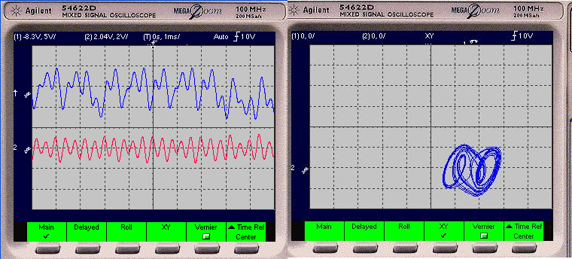
Fig. 5. Chaotic time-domain and phase space waveforms (R = 2050 ohms)
Tamara Blain….
Leon O. Chua (?)

 Manuscript received October 9, 2001. (Write the date on which you submitted your paper for review.) Bharathwaj Muthuswamy is with the Nonlinear Electronics Laboratory (NOEL) at the University of California, Berkeley. Tamara Blain is xxx Leon O. Chua is with NOEL at the University of California, Berkeley.

